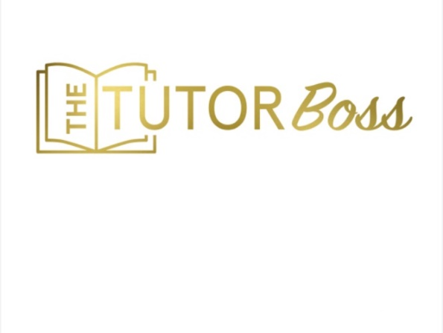

Dear Parent,

TERMS AND CONDITIONS

Firstly, thank you for choosing me to teach and nurture your child. Tutoring isn’t just about the curriculum, but about building skills, confidence, organisational tactics, and much more. I firmly believe all children have the ability to excel in academic subjects; we just have to find the right method of learning for them!

This document contains all the terms and conditions of weekly tutoring/teaching. Please ensure that you read everything carefully, and if you need further clarification don’t hesitate to contact me.

General

Tutees are expected to arrive on time whether in person, or online. In the event of lateness, the tutoring session will still end at the usual time, so as not to impact on the next tutee’s lesson.

Homework will be set as and when needed, rather than following a schedule. If your child requires preparation for a test or exam, their homework may increase accordingly. Year 11 children will be given homework more frequently.

Tutoring is not for the purpose of completing school-given homework. However, I am happy for students or parents to contact me with homework queries if any difficulties arise.

*ABSENCES*

Tutoring is a weekly, term-time commitment, and places abandoned at short notice cannot be easily filled. Therefore, all the weekly sessions you agree to must be paid for, regardless of whether or not they were/will be attended.

If your child is ill or otherwise unable to attend, monies will not be refunded for missed sessions.

COVID-19

If your child has symptoms of the virus, or a heavy cold, please DO NOT send your child for a session. If your child has been off school, please do not send them for their session. Instead, contact me and we will complete the session online.

If your child is self-isolating, it may be possible to move their evening slot to the daytime; however, this is at our discretion and cannot be guaranteed. Typically, the session will need to take place at their usual time. In the event of a local or national lockdown, all sessions will be held online under the same terms and conditions.

Payment

Payment remains as per your initial terms and conditions. Should a fee rise occur, it will only take place at the beginning of a new financial year and you will be advised of the change within a reasonable time period.

Sessions must be paid for in blocks of four weeks minimum, or half-termly.

The above session blocks must be paid for at least seven days in advance. Please do not send your child to a session that has not been paid for, as it will not go ahead.

Payment should be made to the following account:

Ms. C Saccoh
Acct: 04-00-04
Sort code: 99788787

This is a business bank account.

Please ensure you use your child’s name as a reference.

Cancellation

In order to terminate the tutoring relationship, a minimum notice period of one academic term must be given on either side. In the case of unacceptable or unsafe behaviour from the student or parents, I reserve the right to terminate the tutoring relationship immediately.

Feedback

Please feel free to contact me for feedback on your child’s progress. If your child is homeschooled full-time, they will receive a termly written report.

GDPR Statement

Your personal data will be held in a password-encrypted file stored on a password-protected account. Personal data includes:

- Names of student and parent/guardian if applicable
- Age or school year group of student
- Address(es), phone numbers and email address(es) of parent/guardian
- Anything else mutually considered relevant to private tuition.

Email addresses and phone numbers are also stored in email and phone contacts. If a student aged under 18 is emailed or messaged, this will only be done with the explicit consent of the parent. Interaction with clients on social media is only undertaken via business channels for The Tutor Boss. You may occasionally receive an email, text message or WhatsApp with information about additional sessions/services which may be of interest to you.
Your personal information will not be passed to any third parties without your explicit consent unless there is a legal requirement for it to be disclosed.

You have the right to ask for all information held relating to you to be deleted. Please note however, that tuition cannot continue after information is deleted, and that terms and conditions regarding cancellation remain the same. Unless a client has specifically asked for information to be destroyed, client details will be held on file until the end of the following academic year, after a student has finished tuition.

Financial data will be retained for 7 years for tax purposes. When the information is destroyed, all papers will be shredde, to protect the client’s identity. Any data held within computer files will either be anonymized or permanently deleted.

Limitation of Liability

Whilst the Tutor will endeavor to ensure that the student makes satisfactory progress, this cannot be guaranteed, and the Tutor cannot be held accountable for the academic success or otherwise of the student. To the maximum extent permitted by law, the Tutor accepts no liability for any direct or indirect loss or damage, foreseeable or otherwise, including any indirect, consequential, special or exemplary damages arising from the use of the Tutors’ services or any errors or omissions in the contents of the Tutor’s learning materials.

Krissi Saccoh
THE TUTOR BOSS

